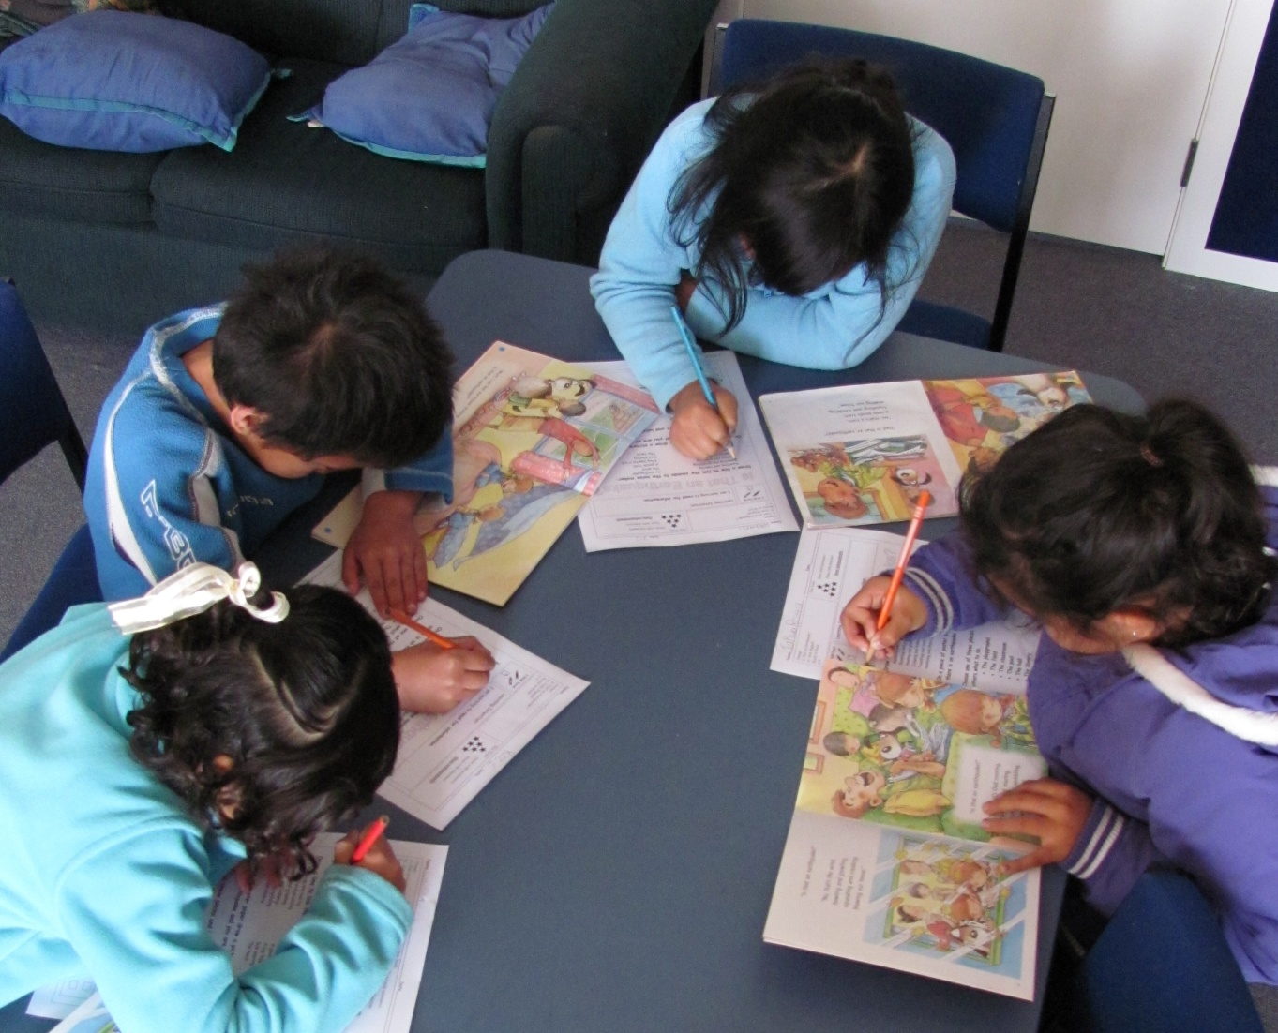

Hello Team

We hope the second term is a great one for you.

I recently visited with the teachers at Roscommon School in Auckland and spent a lovely time sharing our resources. When I asked how they had heard of us – they said that another school had let them know of our resources. Exciting to hear that we are getting referrals especially as we rely so much on ‘word of mouth’ for our marketing. Thank you Lincoln Heights!!!

**We would like to reward schools for any referrals and have decided to deduct $5 from your next year’s sub for every new school you get to sign up with us. All we need to know is who referred them - so when they sign up – just get them to send us a message via the website ‘Contact Us’.**

**We will then let you know that you have a $5 credit!!!**

This is an exciting time for us as we enjoy building new relationships with new customers.

We want to let you know that we have nearly finished all the **red level** resources from books accessed at our second school and those are now being uploaded. We have decided to add a bit of variety to the resource creation and focus on the **silver level** next.

Regards

Lesley and Angela